Green Business Model Training of Trainers Module

Key Concepts

www.switchmed.eu

Contents
- Introduction 3

- Key Concepts for the Green Business Model
Training of Trainers Module 4

  - Sustainable Business 4
  - Eco-innovation 6
  - Eco-design 8
  - Sustainable Consumption and Production 9
  - Circular Economy 11
  - Business Model Canvas 13
  - Lean Startup 15

- References 17

1. Introduction
SwitchMed Green Entrepreneurship Programme supports the creation of National Partnerships of Business Support Organizations (BSOs) targeting green and circular entrepreneurs and start-ups (Switchers National Partnerships) in eight southern Mediterranean countries: Morocco, Algeria, Tunisia, Egypt, Jordan, Palestine, Israel and Lebanon.

As part of the programme, trainers and mentors assigned by the BSOs members of the Switchers National Partnerships will attend a “Training of Trainers” (ToTs) Programme which will allow to transfer SwitchMed sustainable business development methodologies and tools:

- Green Business Model Development Toolkit
- Green Business Plan Development Toolkit
- Eco-Design Tool for Products and Services
- Access to Finance Toolkit
- Access to Market Toolkit
- Impact Monitoring Tool

This document provides conceptual contents complementing the “Green Business Model Development Toolkit” ToTs.

7 key concepts of the “Green Business Model” ToTs are briefly described in the next chapter:

- Sustainable Business
- Eco-innovation
- Eco-design
- Sustainable Consumption and Production
- Circular Economy
- Business Model Canvas
- Lean Startup.

2. Key Concepts
2.1 Sustainable Business
A Sustainable Business not only creates economic value but also environmental and social value. A triple bottom line approach is inherent to circular business models, which are built on the basis of interdependency between the environment, society and the economy.

Sustainable business is not only about reducing the negative environmental impacts of a business with regards to its previous practices and/or when compared to other companies within the sector. The main purpose of a sustainable business is to create environmental value and produce positive ecological and social impacts. Thus, sustainable business models not only create economic value, through the creation of green companies and employment, but also ecological value by addressing environmental challenges, and social value by addressing social needs.

Definition of sustainable business:

Brief definition:

A sustainable business provides commercial solutions to
environmental challenges which are economically viable and
socially empowering.

Comprehensive definition:  Based on the interdependency between the environment, society and economy, a sustainable business provides innovative viable products and services which create environmental value (addressing ecological challenges and reducing environmental impacts) and social value (addressing social needs) by applying eco-innovation, life cycling thinking and eco-design approaches. | 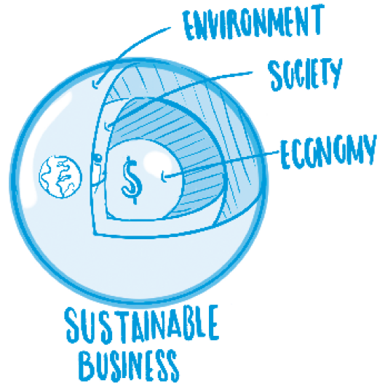
For circular businesses, environmental and social challenges and value define the objectives of the companies and are therefore embedded in their mission and vision. The value proposition development is driven by eco-innovation (see 2.2). The value proposition targets not only customers but also nature and society. In this sense, circular business models broaden the conventional concept of stakeholders within the business model, taking into account structural interaction between the business, customers, society and the environment. Within the green business model, the environment and society are unequivocally considered stakeholders. Finally, life-cycle thinking and eco-design shape the activities and resources required in order to deliver the value in the most sustainable manner possible.

Extract from:

Mosangini, G., Tunçer, B. (2020): Circular Economy Business Strategies. Conceptual Framework to Guide the Development of Sustainable Business Models, UN Environment MAP Regional Activity Centre for Sustainable Consumption and Production (SCP/RAC), Barcelona. Available at: https://bit.ly/CircularBusinessModels

2.2 Eco-innovation
Eco-innovation consists in providing new and alternative solutions, which allow a company to reduce its environmental impacts and/or create environmental value.

Three forms of eco-innovation can be differentiated:

- Process eco-innovation. Production processes are cleaned up to significantly improve resource and energy efficiency, which saves resources and prevents pollution. Existing processes and technologies are improved without transforming what is done. For instance, in the automotive industry, a car could be manufactured using less raw materials and energy and producing less waste.

- Product eco-innovation. The innovated solution changes the main characteristics of the product or service. New processes and technologies transform what is being done, for example, shifting from the production of conventional cars to electric cars.

- System eco-innovation. At this stage, eco-innovation implies transformations at the system level in the value chain and regarding consumption patterns. This is where radical business model innovation is required. System eco-innovation embraces complex changes, usually involving non-technological transformations, various stakeholders and changes in infrastructures. Continuing with the same example, system eco-innovation within the car industry could shift the production and sale of cars towards offering mobility services through car sharing systems. Even better, bicycle sharing systems could substitute vehicles to cover mobility needs

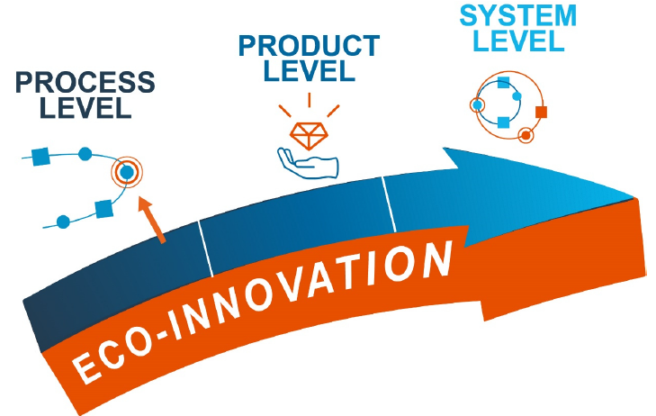

As these three stages indicate, environmental value creation grows progressively with each eco-innovation step. Generally speaking, we cannot expect process and product eco-innovations alone to make the fundamental shift from the linear economy model to the circular economy model, which is required to address the current environmental crisis. Energy and resource efficiency, cleaner production processes, resource-saving products, etc., are necessary but insufficient strategies. Ultimately, a radical transformation is needed at the system level (involving relationships among the stakeholders in the value chain, infrastructures, consumption patterns, etc.) in order to ensure a shift in functionality or modality (e.g. mobility) from an unsustainable solution (e.g. car) to a sustainable option (e.g. bicycle) and to enable a shift to services that dematerialise as much as possible (e.g. telework).

Extract from:

Mosangini, G., Tunçer, B. (2020): Circular Economy Business Strategies. Conceptual Framework to Guide the Development of Sustainable Business Models, UN Environment MAP Regional Activity Centre for Sustainable Consumption and Production (SCP/RAC), Barcelona. Available at: https://bit.ly/CircularBusinessModels

2.3 Eco-design
Eco-design is the main tool available for sustainable businesses to improve their environmental performance and reduce and minimize the environmental impacts of their products and services.

Eco-design consists in taking into account and assess from the design stage (of a product or service and its business model) any potential environmental impact. Impacts on the environment have to be systematically evaluated at all stages of the lifecycle of the product/service: design; extraction and purchasing of raw materials; production; packaging and distribution; sales and marketing, product use; end of life management.

Every product (and service) has environmental impacts and it is usually estimated that over 80% are determined during the design phase. Analysing during the design stage the entire cycle of products and services through eco-design will allow us to design and implement strategies to improve our environmental performance. Besides improving ecological performance, eco-design also allows sustainable businesses to reduce their costs throughout the entire life cycle of their products/services.

Eco-design requires to assess the environmental performance of our product/service and to identify opportunities and strategies to reduce environmental impacts throughout all stages of its lifecycle:
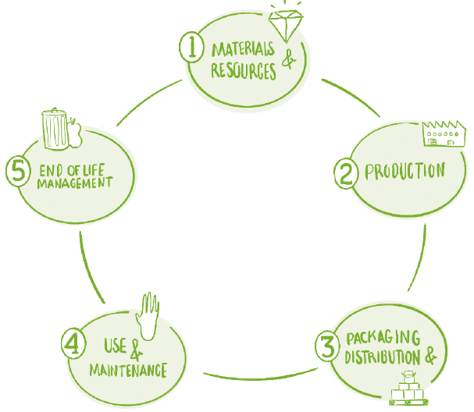

2.4 Sustainable Consumption and Production
Sustainable Consumption and Production (SCP) is one of the main global approaches adopted to revert the destructive impacts that the global economy has on the sustainability of natural ecosystems and societies. SCP has been embraced in Rio Earth Summit in 1992, in the Rio+20 Summit through the adoption of the 10-Year Framework of Programmes and integrated into the 2030 Agenda for Sustainable Development adopted by all United Nations Member States in 2015: Sustainable Development Goal 12.

SCP aims at doing more and better with less. As defined by the Oslo Symposium in 1994, SCP is about

"the use of services and related products, which respond to basic needs and bring a better quality of life while minimizing the use of natural resources and toxic materials as well as the emissions of waste and pollutants over the life cycle of the service or product so as not to jeopardize the needs of further generations”.

SCP is a holistic approach requiring systemic change. As illustrated in the figure below, SCP involves a wide set of strategies to be implemented by various categories of stakeholders:

- Policy-makers should adopt regulatory frameworks enabling SCP
- Industries must adopt resource efficiency, cleaner production and circular economy approaches
- Public and private financial actors have to deploy financial instruments that support SCP
- Civil society ought to promote sustainable consumption solutions and demand sustainable products and services
- Knowledge of SCP should be developed and disseminated
- New companies and start-ups should adopt green and circular innovative business models

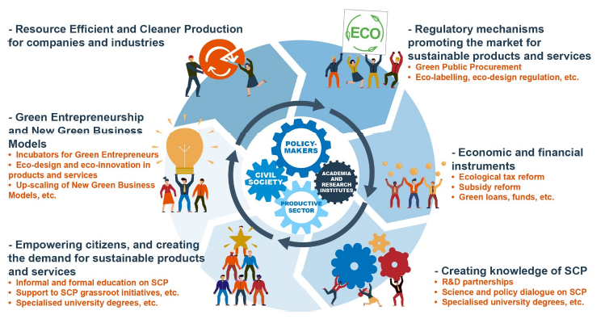

Extract from / sources:

Mosangini, G., Tunçer, B. (2020): Circular Economy Business Strategies. Conceptual Framework to Guide the Development of Sustainable Business Models, UN Environment MAP Regional Activity Centre for Sustainable Consumption and Production (SCP/RAC), Barcelona. Available at: https://bit.ly/CircularBusinessModels

https://www.un.org/sustainabledevelopment/sustainable-consumption-production/

https://www.unenvironment.org/explore-topics/resource-efficiency/what-we-do/sustainable-consumption-and-production-policies

2.5 Circular Economy
The Ellen MacArthur Foundation provides the following definition of Circular Economy:

“Looking beyond the current take-make-waste extractive industrial model, a circular economy aims to redefine growth, focusing on positive society-wide benefits. It entails gradually decoupling economic activity from the consumption of finite resources, and designing waste out of the system. Underpinned by a transition to renewable energy sources, the circular model builds economic, natural, and social capital. It is based on three principles: Design out waste and pollution; Keep products and materials in use; Regenerate natural systems”.

“The model distinguishes between technical and biological cycles. Consumption happens only in biological cycles, where food and biologically-based materials (such as cotton or wood) are designed to feed back into the system through processes like composting and anaerobic digestion. These cycles regenerate living systems, such as soil, which provide renewable resources for the economy. Technical cycles recover and restore products, components, and materials through strategies like reuse, repair, remanufacture or (in the last resort) recycling.” (www.ellenmacarthurfoundation.org)

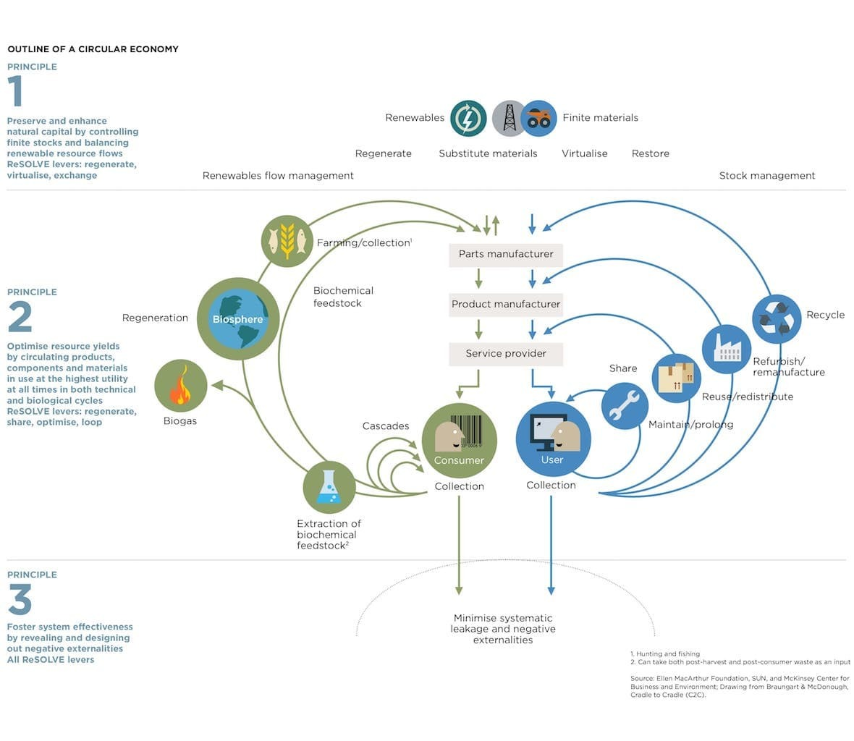

Decoupling economic growth from resource use and implementing regenerative schemes which could give back to the planet more than they take, would allow to replace economic systems within planetary boundaries.

Extract from / sources:

www.ellenmacarthurfoundation.org

https://ec.europa.eu/environment/circular-economy/

2.6 Business Model Canvas
Following Osterwalder and Pigneur, 2010:

“A business model describes the rationale of how an organization creates, delivers, and captures value”.

A business model can be synthetized and described through a Business Model Canvas and his building blocks (see figure below).

The different components answer the main questions which define the nature of the business model:

- Why? Mission, vision and objectives of the company
- Who? Key stakeholders and customer segments
- What? The value proposition
- How? Key activities and resources; customer relationships and channels; cost structure; and revenue streams

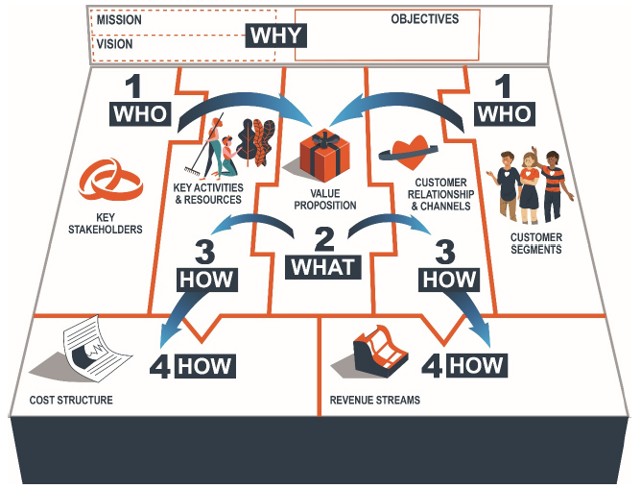
Business Model Canvas
Adapted from Osterwalder and Pigneur, 2010.

A business model canvas essentially describes the value proposition of the company and how value is created, delivered to the customers and captured by the company.

SwitchMed Green Business Model methodology has adapted the Business Model Canvas to a triple bottom line approach considering the interdependency between the environment, society and the economy. Thus, in addition to economic value, environmental and social value creation and distribution has been considered in the business model development tool. Furthermore, all environmental and social impacts of the business are considered and assessed.

Extract from / sources:

Mosangini, G., Tunçer, B. (2020): Circular Economy Business Strategies. Conceptual Framework to Guide the Development of Sustainable Business Models, UN Environment MAP Regional Activity Centre for Sustainable Consumption and Production (SCP/RAC), Barcelona. Available at: https://bit.ly/CircularBusinessModels

Osterwalder, A., Pigneur, Y. (2010), Business Model Generation: A Handbook for Visionaries, Game Changers, and Challengers, John Wiley & Sons, Hoboken, New Jersey.

Regional Activity Centre for Sustainable Consumption and Production (SCP/RAC) (2015), Create your Green Business! The Handbook for Green Entrepreneurs in the Mediterranean, SCP/RAC, Barcelona.

Regional Activity Centre for Sustainable Consumption and Production (SCP/RAC) (2015), Create your Green Business! The Workbook for Green Entrepreneurs in the Mediterranean, SCP/RAC, Barcelona.

https://www.strategyzer.com/

2.7 Lean Startup
Most new businesses tend to fail, mostly because their novel products and services do not attract enough customers. The Lean Startup methodology considers that this mainly happens due to a lack of testing of assumptions underlying the business models.

Usually, entrepreneurs tend to develop during a long time a detailed business plan (often hiding their product/service idea) and then seek funding and investment in order to start their company. By contrast, the Lean Startup approach encourages entrepreneurs to test their business models and product/service from the very beginning, looking for feedback from potential customers and early adopters and continuously adjusting the idea according to the reactions. The approach can reduce costs, risks and time to validate a business model.

The Lean Startup model advises to develop hypothesis while developing the business model and start testing such assumptions as soon as possible with potential customers. Likewise, entrepreneurs should offer a minimum viable product to initial customers as quickly as possible and systematically collect reactions.

While developing a business model, hypothesis are formulated concerning the value proposition, the product or service, the customers, as well as the rest of the building blocks of the canvas. The Lean Startup approach requires to progressively and continuously test these assumptions requesting feedback from early adopters and other stakeholders. Gathered reactions will allow entrepreneurs to validate the assumptions or adapt and pivot the business model, the product/service and the value proposition accordingly to what they learned through the tests.

“A core component of Lean Startup methodology is the build-measure-learn feedback loop. The first step is figuring out the problem that needs to be solved and then developing a minimum viable product (MVP) to begin the process of learning as quickly as possible. Once the MVP is established, a startup can work on tuning the engine. This will involve measurement and learning and must include actionable metrics that can demonstrate cause and effect question.”  http://theleanstartup.com | 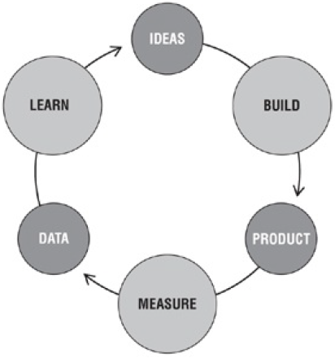  Figure from Ries (2011)

SwitchMed Green Business Model Development Methodology has been created adopting the Lean Startup approach, ensuring iterative testing of the sustainable business model through the consultation of potential customers and other stakeholders and the consequent validation of the main hypothesis and/or the adaptation and fine-tuning of the green business idea and the pivoting of the value proposition. | 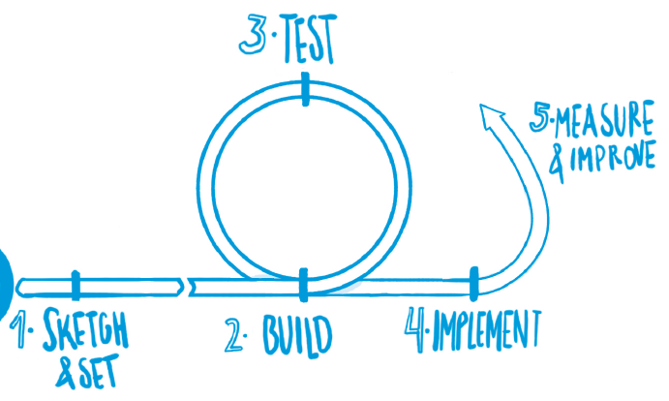

Extract from / sources:

Ries, E. (2011), The Lean Startup. How Today’s Entrepreneurs Use Continuous Innovation to Create Radically Successful Businesses, Crown Business, New York.

http://theleanstartup.com

References

Mosangini, G., Tunçer, B. (2020): Circular Economy Business Strategies. Conceptual Framework to Guide the Development of Sustainable Business Models, UN Environment MAP Regional Activity Centre for Sustainable Consumption and Production (SCP/RAC), Barcelona. Available at: https://bit.ly/CircularBusinessModels

Osterwalder, A., Pigneur, Y. (2010), Business Model Generation: A Handbook for Visionaries, Game Changers, and Challengers, John Wiley & Sons, Hoboken, New Jersey.

Regional Activity Centre for Sustainable Consumption and Production (SCP/RAC) (2015), Create your Green Business! The Handbook for Green Entrepreneurs in the Mediterranean, SCP/RAC, Barcelona.

Regional Activity Centre for Sustainable Consumption and Production (SCP/RAC) (2015), Create your Green Business! The Workbook for Green Entrepreneurs in the Mediterranean, SCP/RAC, Barcelona.

Ries, E. (2011), The Lean Startup. How Today’s Entrepreneurs Use Continuous Innovation to Create Radically Successful Businesses, Crown Business, New York.

United Nations, 2030 Agenda for Sustainable Development – Sustainable Development Goal 12. Responsible Consumption and Production: https://www.un.org/sustainabledevelopment/sustainable-consumption-production/

https://ec.europa.eu/environment/circular-economy/

www.ellenmacarthurfoundation.org

https://www.strategyzer.com/

http://theleanstartup.com

This publication was produced with the financial support of the European Union. Its contents are the sole responsibility of SwitchMed and do not necessarily reflect the views of the European Union.

www.switchmed.eu

The terms sustainable business, circular business and green business are used interchangeably.

